AOC-0 Interim orbital capsule
Specifications and assembly instructions
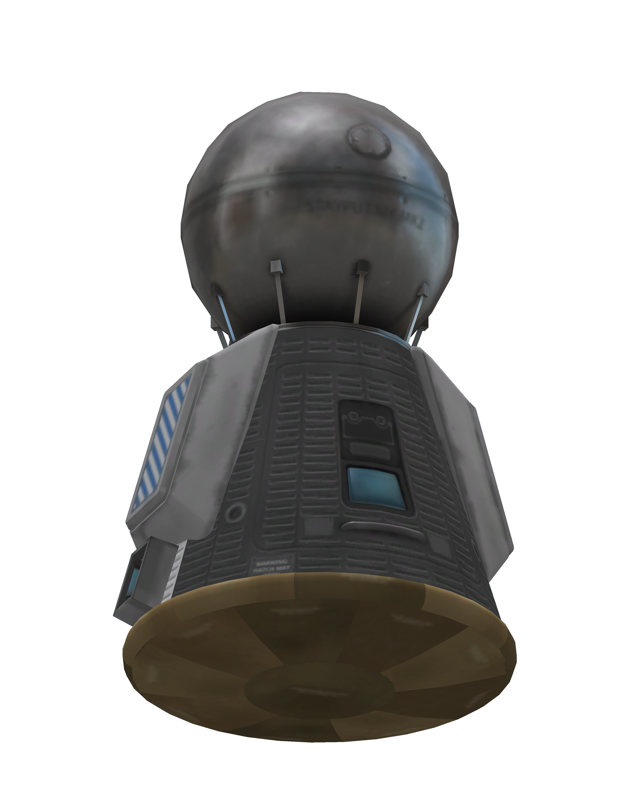

Description
The AOC-0 is a low tech interim capsule that can be used for short suborbital or orbital missions. The capsule is battery powered and has a redundant short range radio transceiver, limiting its orbital endurance.

Specifications
Parameter | Value | Unit | Notes
Mass | 1210 | Kg
Total EC | 310 | Units
EC endurance | 134 | Minutes | Hibernating
EC endurance | 64 | Minutes | Full operation
EC consumption | 0.0884 | EC/sec | Full operation
EC consumption | 0.04 | EC/sec | Hibernating

Assembly and maintenance instructions

Parts list
1x Mk1 Command Pod
1x Probodobodyne Stayputnik
1x Heat Shield (1.25m)
2x Mk2 Radial-Mount Parachute
2x Reflectron DP-10
1x 2HOT Thermometer
1x PressMat Barometer

Assembly procedure
- Start with Mk1 pod
  - Drain all monopropellant
  - Remove all equipment from inventory slots
  - Set spare parts to 5
- Install heat shield axially on bottom of capsule
  - Set ablator to 0
- Install Stayputnik computer axially on top of capsule
  - Stayputnik name tag on window side
  - Set "Hibernate on warp" to "Auto"
  - Set "Hibernate" to "Off"
  - Set battery flow priority to -1
- Install radio antennas radially on pod
  - Mirror symmetry
  - Aligned with flag's sides
  - Antennas should run full length of capsule
  - Touching stayputnik on top and heat shield on bottom
- Install parachutes radially on sides of pod
  - 2x symmetry with snap
  - On white lines of Mk1 in default skin
  - On top of pod, sides should touch end of pod, no part should be visible protruding on top of capsule
  - Angle 10
  - Altitude 750
  - Pressure 0.6
- Install barometer and thermometer below parachutes
- Barometer to left of hatch, thermometer to right
- Bottom of pod, bottom of instrument should touch heat shield

Post flight maintenance
Part | System | Action | Notes
Stayputnik | Battery | Fill
 | Command | Check hibernation | Hibernate to off  Hibernate in warp to on
Mk1 pod | Battery | Fill
 | Monoprop | Empty
 | Spare parts | 5
 | Food | Fill
 | Water | Fill
 | Oxygen | Fill
 | Carbon Dioxide | Empty
 | Waste | Empty
 | Waste water | Empty
 | Reaction wheels | Active/Normal
Parachutes | Pressure | 0.6
 | Altitude | 750
 | Deploy | When safe
Radios | Status | Enabled

Pre mission checks
- Check parachute parameters
  - Pressure 0.6 Altitude 750
- Check radios
  - Both ON
- Check supplies
  - EC full
  - Life support > 20%
- Check computer
  - Not hibernating
  - Auto hibernate in warp

Systems

Electrical

Description
The electrical system is supplied by the Mk1 pod batteries. There is a secondary battery in the Stayputnik computer that is set to be drained after the main battery is drained. This is only a last resort reserve and re-entry should be initiated as soon as possible when running on this battery.

System consumption
Class | System | Consumption | Unit | Notes
Computer | Total | 0.0284 | EC/sec
 | Stayputnik | 0.0284 | EC/sec | Full operation, divide by 1000 for hibernation
Radios | Total | 0.02 | EC/sec
 | DP-10 (right) | 0.01 | EC/sec
 | DP-10 (left) | 0.01 | EC/sec
Life support | Total | 0.04 | EC/sec
Attitude | Total | 0.2 | EC/sec
 | Mk1 wheel | 0.2 | EC/sec
Sensors | Total | 0.0134 | EC/sec
 | Thermometer | 0.0067 | EC/sec
 | Barometer | 0.0067 | EC/sec

Total EC consumption
Situation | Consumption | Unit | Notes
Maneuvering | 0.2884 | EC/sec | Sensors inactive
Full op + sensors | 0.102 | EC/sec
Full operation | 0.0884 | EC/sec
Hibernating | 0.06 | EC/sec
Hibernating, 1 radio | 0.05 | EC/sec
Hibernating, no comms | 0.04 | EC/sec | Requires crew to get out of this state

Life support
The life support is a standard TAC LS unit taking supplies from the Mk1 capsule. This is enough to keep a kerbonaut alive for 3 days. This is much greater than the availability of electrical power (even in deep hibernation). The availability of power is the limiting factor and the capsule’s endurance is 2 hours.
Resource | Endurance | Unit | Notes
Oxygen | 18 | hours
Water | 18 | hours
Food | 18 | hours
Electric power | 2.15 | hours | Limiting factor, full hibernation

Attitude control

Reaction Wheels
The only way of controlling attitude is in the Mk1 reaction wheel. Loss of the wheel prevents the capsule from exerting any attitude control.

Orbital maneuvering
The AOC-0 is not capable of maneuvering in orbit and requires an external service module for all operations, including deorbiting.

Communications
The AOC-0 contains dual Reflectron DP-10 radios. These are enough to maintain communications when in view of the KSC. The system is capable of keeping in contact with the KSC at a distance of 4125 Km and with an HG-5 equipped satellite at 2310 Km.

Antenna ranges
(assumes root model, 0.5 antenna multiplier and 0.5 multiple antenna bonus)
Situation | Range | Unit | Power | Unit | Notes
Single radio | 250 | Km | 0.01 | EC/sec
Dual radios | 375 | Km | 0.02 | EC/sec
To compute effective range, employ the root model equation.

where r1 should be the capsule’s range and the r2 range for an HG-5 is 10000Km and KSC is 37500Km.

Science
The capsule has a basic science instrument set containing a barometer and thermometer. These instruments have a storage capacity for one measurement. Data can be moved to the Mk1 pod via EVA or transmitted to KSC via radio.
Transmitting science data imposes a large power drain and should not be done without previous planning.

Re-entry
AOC-0 capsules can re-enter Kerbin’s atmosphere passively. Once contact with the atmosphere is made, the capsule should orient itself in the proper shield first attitude. The shield does not use ablator.
Attaining re-entry attitude requires an external means of propulsion. The AOC-0 capsule is not capable of performing orbital maneuvers.

Landing
Landing is provided by two Mk2 parachutes. The system is redundant and landing can be safely achieved even if a single parachute deploys.
The main parachutes allow a landing speed of 3.4 m/s at sea level. Only one parachute is needed for a safe landing (at about 5.5 m/s). The parachutes open partially at an altitude of 3000 m (0.6 pressure) and fully at 750 metres. They need to be adjusted if the predicted course will cause the landing to happen on mountaineous terrain.
WARNING: Avoid mountains. Plan ahead before executing the re-entry procedure. Consider prematurely opening the parachutes to shorten downrange if necessary.

